**Places to Hide in God**

This week I came across a verse of scripture that tugged at my heart. This scripture is found in **Psalms 27:5**…**For in the time of trouble He shall hide me in His pavilion; In the secret place of His tabernacle, He shall hide me; He shall set me** **high upon a rock. NKJV**

As I read this verse, I began to understand why the pain and hurt that I experienced during some of the darkest times of my life did not take me out. My mind was still intact, depression was far from me, and family was spared. Now I know that during these times, God hid me away and kept me safe until I was able to securely stand strong again. As I studied, I could see that Psalms 27 was just a fraction of how and where God hides His people. There are so many other scriptural references that teaches us about God’s hiding places for His people.

There are some who believe that you are either in a storm, going through a storm, or coming out of a storm. Maybe in one of these statements you might be able to locate yourself. In either case, we can confidently say that in some way, shape, form, or fashion, trouble comes to all of us at some point in our lives. **But God…**

David understood this better than most. He was always a target for the devil. Some of his problems were of his own doing, others were because of his love for God and His people. Let’s look at what David wrote about this topic. He said, “for in the time of trouble.” Here David is not denying that trouble would come in his life. It’s what happens after the trouble comes. Thus, he uses the words ‘for in” to show the relationship between the trouble and God’s solution to the problem---and that was providing a place for him to hide.

**The first hiding place found in this passage was: God’s pavilion**…A pavilion is a very large tent or a shelter in a park or a garden. The question is why would God use an open space such as a shelter as a way of hiding David?

Look at Psalms 91…This verse states, He that dwells in **the secret place** (bold print mine) of the most High God, shall abide under the shadow of the Almighty. Secret place in Psalms 91:1 is the Hebrew word satar. Many contemporary versions will render this word to mean shelter. It has the same meaning as the word pavilion.

I have a structure in my backyard that we often use as a shelter. When my husband and I are working outside in our garden and it gets to hot, or it begins to rain, or we just need a break, we step into this shelter and we are protected from the elements, we can rest, and be at peace.

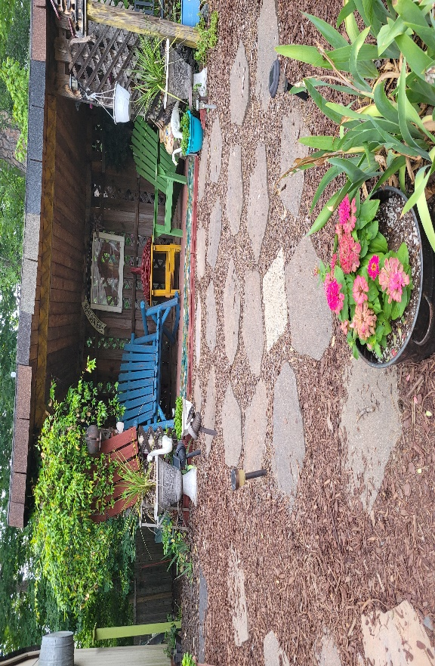

As I prayed and pondered all of this, I realized that the bigness of our God overshadows, hovers over, and then cover us just like a shelter. God becomes the covering that we need for safety. He provides protection from the storms of life, the fiery darts of the evil one, and all other dangers that might seek to harm us.

**The second hiding place described in this passage was:** the secret place of His tabernacle. The word tabernacle in Hebrew means mishkan, the root word that means to dwell or tent. Notice the word **His** which denotes that this place of shelter belongs to God. Our enemies cannot come into this place, we cannot be found when He hides us. People who come into our homes can only come in when they are invited otherwise, they are trespassing and violating our dwelling. It is the same with our God. You see, the tabernacle was the dwelling-place of God on earth which means that God would hide us just as if He were allowing us to enter His own dwelling, His own home. He would permit us to come close to Himself; He would care for and protect us just like one of His own family members; just as you or I would protect those who are in our own households.

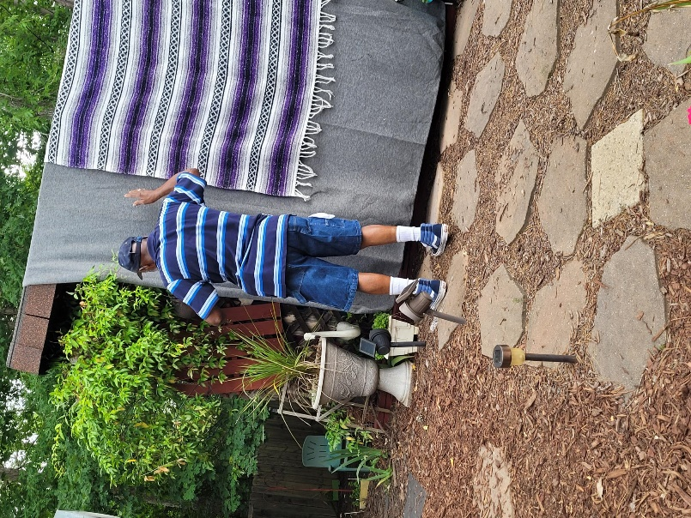 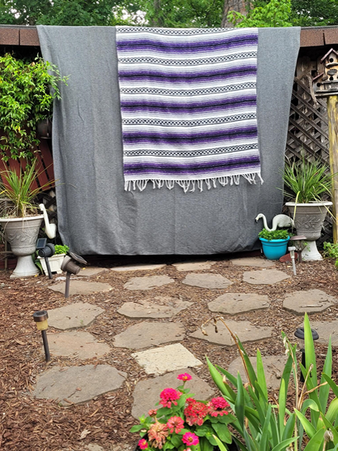

**The third hiding place found:** high upon a rock. When I consider how a rock was characterized by Jesus, He presented it as one of strength, constancy, and steadfastness. Here are a few scriptures to use in your quiet time to learn more about our God as a Rock, His strength, and His steadfastness: **Psalm 18:2, Matthew 16:8, Isaiah 26:4, Matthew 7:24-27.** If you are feeling like your life is on shaky grounds, allow the Holy Spirit to minister, life, help, hope, healing, and support. Only God knows how to steady the ground under you.

**In Psalms 25,** David said, the Lord set him on a high rock. How did He get there? Well, we all know from scriptures that David was a man after God’s own heart. In 2 Samuel 6 **(NKJV)**, we read the story about King David dancing when the Ark of the Covenant was brought into Jerusalem. David’s heart of worship was on full display, brimming over with fanatical and passionate dancing and celebration. The Bible said he danced before the Lord with all his might. He did not care what he looked like or what others thought about him. David didn’t hold back. His desire was to praise God for his goodness, for His mercy, and for helping Him to bring the Ark back to Jerusalem. The Bible declares that God inhabits the praises of His people. **(KJV)** When we worship Him with our whole hearts, unashamedly, without reservation, and without any inhibition, He raises us up high above our enemies so they cannot harm us. This is why David could say of the Lord, “He set me high upon a rock”. Worship elevates us into the presence of the Lord. It ushers us into His shelter, brings us into His dwelling, lifts us up, set us on a firm foundation, and hide us until the danger has passed over.

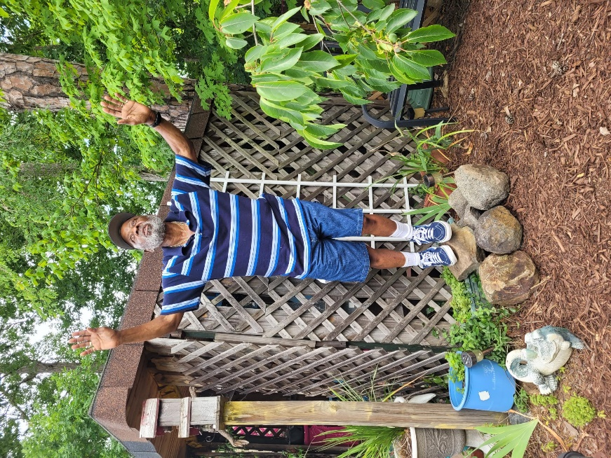

This was observed when Michal, David’s wife, tried to make David feel bad about the way he was worshipping. David was escorted to a place in God to where when his wife began belittling his worship and his behavior during dance, he ignored her jabs and responded this way: “It was before the Lord, who chose me instead of your father and all his house, to appoint me ruler over the people of the Lord, over Israel. Therefore I will play music before the Lord. And I will be even more undignified than this, and will be humble in my own sight. But as for the maidservants of whom you have spoken, by them I will be held in honor.” (**NKJV)**

David let his wife know that his worship was for God and God alone. We must also be willing to defend our commitment when it comes to the things of God. If we do not, there will always be a Michal present to demean what we are doing for Him. Remember. God has not given us the spirit of fear. Speak up and inform the devil who your worship is for. Jesus did! After He was led into the wilderness by the Holy Spirit, the Bible said Satan took Jesus on a high mountain and offered Him kingdoms and authority because it was given to him. He wanted Jesus to worship him. Here is how Jesus responded in Luke 4:8… **“Get behind Me, Satan! For it is written, ‘You shall worship the Lord your God, and Him only you shall serve.” (NKJV)** So good! Jesus put Satan in his place. How much more should you and I defend what belongs to God?

Here is my last scripture to show we have a hiding place in Jesus. Colossians 3:3…declares for **you died**…meaning when we accepted Jesus as our Lord, Master, and personal Savior, and we were baptized into His resurrection, life as we knew it was buried with Him and our sins were cast as far as the east is from the west. Consequently, our lives were then hidden with Christ in God. The verse continues saying, “when Christ who is our life appears, then we also will appear with Him in glory.” (**NKJV)**

That is good news to me because I have security, protection, and a surety that regardless of what I go through in this life, the highs, and the lows, the good, and the bad, bountiful, or lean times, God has already prepared a place for me to be hidden until the storm passes over or He returns to get me. Either way I’m safe. What about you? Have YOU made your commitment to the Lord by inviting Jesus into your life? Or maybe you need to renew your walk with Him? Whichever applies to you, now is the time to make your call and election sure in God.

